**Configuration of Dynamic routing.  
  
Intended Learning Outcome:**a. Set up of several routers and configure them for data sends among them .  
c. Create dynamic routing networks.

**Expected skills:**a. Router and end device Configuration.  
b. Connecting different networks with dynamic routing.

c. Basic knowledge about clock rate and bandwidth.

**Tools Required:**a. Packet Tracer.  
  
**Session Detail:**

In this session the RIP protocol for the following topology will be applied.

[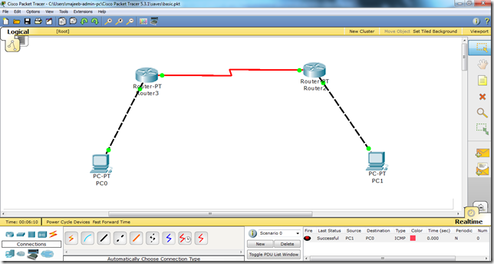](http://lh3.ggpht.com/-8eScR4zMOEI/UIG0l-x2QII/AAAAAAAAAZ0/8FLzOIjOC14/s1600-h/rip%25255B3%25255D.png)

Now, we will follow the steps as mentioned in the following:   
i. We will assign IP addresses to all the fast Ethernet and serial interfaces respectively.

ii. We will also assign IP addresses and default gateways to all the PCs.  
iii. We will change the state of the interfaces from down to UP.   
Then, after we are done with the basic step. We will apply RIP protocol commands on both routers and check the configuration.

Main Commands for dynamic routing(RIP) :

|  |  |
| --- | --- |
| Router(config)# router rip | Enable RIP as routing protocol |
| Router(config-router)# network w.x.y.z | w.x.y.z is the network number of the directly connected network you want to advertise. |

**Post Lab Exercise: Configure the following topology with dynamic routing.**

